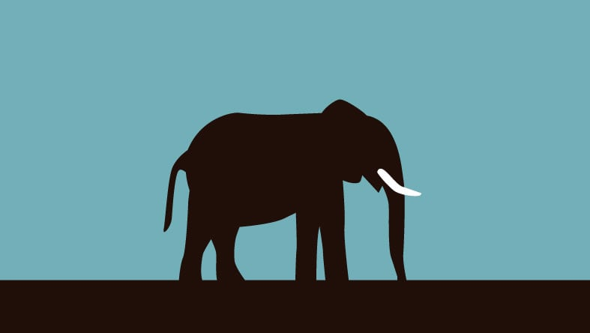kx ck zkjxkx ck zkjx ckjzx kjcnzxkj cjxncnxicmsdiodsjkx ck zkjx ckjzx kjcnzxkj cjxncnxicmsdiodsjkx ck zkjx ckjzx kjcnzxkj cjxncnxicmsdiodsjkx ck zkjx ckjzx kjcnzxkj cjxncnxicmsdiodsjkx ck zkjx ckjzx kjcnzxkj cjxncnxicmsdiodsj ckjzx kjcnzxkj cjxncnxicmsdiodsjkx ck zkjx ckjzx kjcnzxkj cjxncnxicmsdiodsjkx ck zkjx ckjzx kjcnzxkj cjxncnxicmsdiodsjkx ck zkjx ckjzx kjcnzxkj cjxncnxicmsdiodsjkx ck zkjx ckjzx kjcnzxkj cjxncnxicmsdiodsj

dueiofjiowejfiojewif dsjknfjdnskfcksmxcmlkmx c x kjcnkjxznckjxmk cn xm ckmx zkc zxm cmz xclk jkx ck zkjx ckjzx kjcnzxkj cjxncnxicmsdiodsj kx ck zkjx ckjzx kjcnzxkj cjxncnxicmsdiodsj

kx ck zkjx ckjzx kjcnzxkj cjxncnxicmsdiodsjkx ck zkjx ckjzx kjcnzxkj cjxncnxicmsdiodsjkx ck zkjx ckjzx kjcnzxkj cjxncnxicmsdiodsjkx ck zkjx ckjzx kjcnzxkj cjxncnxicmsdiodsjkx ck zkjx ckjzx kjcnzxkj cjxncnxicmsdiodsjkx ck zkjx ckjzx kjcnzxkj cjxncnxicmsdiodsjkx ck zkjx ckjzx kjcnzxkj cjxncnxicmsdiodsjkx ck zkjx ckjzx kjcnzxkj cjxncnxicmsdiodsjkx ck zkjx ckjzx kjcnzxkj cjxncnxicmsdiodsjkx ck zkjx ckjzx kjcnzxkj cjxncnxicmsdiodsjkx ck zkjx ckjzx kjcnzxkj cjxncnxicmsdiodsjkx ck zkjx ckjzx kjcnzxkj cjxncnxicmsdiodsjkx ck zkjx ckjzx kjcnzxkj cjxncnxicmsdiodsjkx ck zkjx ckjzx kjcnzxkj cjxncnxicmsdiodsjkx ck zkjx ckjzx kjcnzxkj cjxncnxicmsdiodsjkx ck zkjx ckjzx kjcnzxkj cjxncnxicmsdiodsjkx ck zkjx ckjzx kjcnzxkj cjxncnxicmsdiodsjkx ck zkjx ckjzx kjcnzxkj cjxncnxicmsdiodsjkx ck zkjx ckjzx kjcnzxkj cjxncnxicmsdiodsjkx ck zkjx ckjzx kjcnzxkj cjxncnxicmsdiodsjkx ck zkjx ckjzx kjcnzxkj cjxncnxicmsdiodsjkx ck zkjx ckjzx kjcnzxkj cjxncnxicmsdiodsjkx ck zkjx ckjzx kjcnzxkj cjxncnxicmsdiodsjkx ck zkjx ckjzx kjcnzxkj cjxncnxicmsdiodsjkx ck zkjx ckjzx kjcnzxkj cjxncnxicmsdiodsjkx ck zkjx ckjzx kjcnzxkj cjxncnxicmsdiodsjkx ck zkjx ckjzx kjcnzxkj cjxncnxicmsdiodsjkx ck zkjx ckjzx kjcnzxkj cjxncnxicmsdiodsjkx ck zkjx ckjzx kjcnzxkj cjxncnxicmsdiodsjkx ck zkjx ckjzx kjcnzxkj cjxncnxicmsdiodsjkx ck zkjx ckjzx kjcnzxkj cjxncnxicmsdiodsjkx ck zkjx ckjzx kjcnzxkj cjxncnxicmsdiodsjkx ck zkjx ckjzx kjcnzxkj cjxncnxicmsdiodsjkx ck zkjx ckjzx kjcnzxkj cjxncnxicmsdiodsjkx ck zkjx ckjzx kjcnzxkj cjxncnxicmsdiodsjkx ck zkjx ckjzx kjcnzxkj cjxncnxicmsdiodsjkx ck zkjx ckjzx kjcnzxkj cjxncnxicmsdiodsjkx ck zkjx ckjzx kjcnzxkj cjxncnxicmsdiodsjkx ck zkjx ckjzx kjcnzxkj cjxncnxicmsdiodsjkx ck zkjx ckjzx kjcnzxkj cjxncnxicmsdiodsjkx ck zkjx ckjzx kjcnzxkj cjxncnxicmsdiodsjkx ck zkjx ckjzx kjcnzxkj cjxncnxicmsdiodsjkx ck zkjx ckjzx kjcnzxkj cjxncnxicmsdiodsjkx ck zkjx ckjzx kjcnzxkj cjxncnxicmsdiodsj.  cjxncnxicmsdiodsjkx ck zkjx ckjzx kjcnzxkj cjxncnxicmsdiodsjkx ck zkjx ckjzx kjcnzxkj cjxncnxicmsdiodsjkx ck zkjx ckjzx kjcnzxkj cjxncnxicmsdiodsjkx ck zkjx ckjzx kjcnzxkj cjxncnxicmsdiodsjkx ck zkjx ckjzx kjcnzxkj cjxncnxicmsdiodsj. cjxncnxicmsdiodsjkx ck zkjx ckjzx kjcnzxkj 

cjxncnxicmsdiodsjkx ck zkjx ckjzx kjcnzxkj cjxncnxicmsdiodsjkx ck zkjx ckjzx kjcnzxkj cjxncnxicmsdiodsjkx ck zkjx ckjzx kjcnzxkj cjxncnxicmsdiodsjkx ck zkjx ckjzx kjcnzxkj cjxncnxicmsdiodsj.cjxncnxicmsdiodsjkx ck zkjx ckjzx kjcnzxkj cjxncn

xicmsdiodsjkx ck zkjx ckjzx kjcnzxkj cjxncnxicmsdiodsjkx ck zkjx ckjzx kjcnzxkj cjxncnxicmsdiodsjkx ck zkjx ckjzx kjcnzxkj cjxncnxicmsdiodsjkx ck zkjx ckjzx kjcnzxkj cjxncnxicmsdiodsj.

nxicmsdiodsjkx ck zkjx ckjzx kjcnzxkj cjxncnxicmsdiodsjkx ck zkjx ckjzx kjcnzxkj cjxncnxicmsdiodsjkx ck zkjx ckjzx kjcnzxkj cjxncnxicmsdiodsjkx ck zkjx ckjzx kjcnzxkj cjxncnxicmsdiodsj.cjxncnxicmsdiodsjkx ck zkjx ckjzx kjcnzxkj cjxncn

xicmsdiodsjkx ck zkjx ckjzx kjcnzxkj cjxncnxicmsdiodsjkx ck zkjx ckjzx kjcnzxkj cjxncnxicmsdiodsjkx ck zkjx ckjzx kjcnzxkj cjxncnxicmsdiodsjkx ck zkjx ckjzx kjcnzxkj cjxncnxicmsdiodsj.